Information Architects Institute

Content Inventory – a map based approach

By Patrick C. Walsh

In designing a content inventory tool it was apparent that any inventory needed to have two attributes –
- Data attribute – e.g. Excel or Access sheets listing unique page number, title, content owner, approval/review dates etc.etc.
- Structural attribute – a list can only convey so much. I needed to know how all the pages and content were connected together

The data attribute is easily achieved. Just set up an Access database with all the fields you require for your project.

For the structural attribute I used the customised Visio ‘Metro’ stencil. You will find the elements in the map below in the stencil. They are accessed by simply clicking and dragging into position. Start with the big station title for your page title and the big station roundel. This is the main indicator that says ‘you are here’. I have also repeated the page title at the top of the map.
Drag and drop a section of line. The line will be in red so change the colour if required. Different coloured lines can mean anything. In the example below the green line pages are sub-pages, the blue line pages belong to other sections within the site and the red line pages are external links. Before compiling the map it will be necessary to agree what each colour represents e.g. product line, category, page relationship etc. I also use different colours for the station titles – grey meaning the page is still under construction and blue denoting that the link is contextual.
In my maps ‘direction of travel’ is from left to right, which for some reason seems logical to me, but this, along with colours, text colour, positioning etc should be decided on by the person or team using the map to ensure that it makes sense to them. ‘Rules’ once adopted must be consistent for each page so it is worth while giving this a bit of thought before compiling a map.

Once the map has been assembled and its structure decided on the titles can then be linked to a webpage, wireframe or requirements statement. In my case I have linked the station titles to pages in my organisation’s intranet. When sub-maps have been created the station roundels can then be linked to the sub-maps. I have found it really worthwhile to try and create as much structure as possible and to think the concept and categories through by using the map before coding or re-organising takes place.

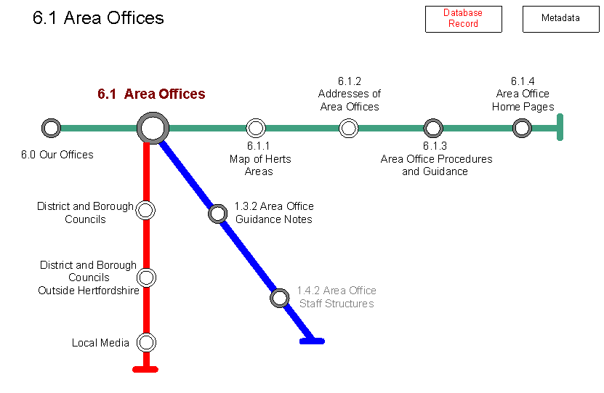

Link to intranet page

Link to sub-map

The whole document can then be saved as a webpage. This will allow you to quickly click from map to sub-map using the roundels and your webpage, wireframe or requirements statement is only one click away.

The problem now is that your content inventory is effectively in two halves – data in one, structure in the other. You need to connect them. Select -
Tools/Add Ons/Visio Extras/Link to Database
You will now be able to link a shape to a particular Access database record. When saved again as a webpage, by using ‘Control + Click’ the database fields can be displayed on the left hand side of the screen. You can now view both the data and the structure at the same time.

Please be aware that Visio 2003 does not support the automatic updating of database information and if you change information on a database page you will need to right click on your database shape and select ‘Refresh shape properties’. This doesn’t however take too long and I have not found it a great problem. However I believe that the latest version of Visio does enable automatic updating (see link below)

http://office.microsoft.com/training/Training.aspx?AssetID=RC101981801033&CTT=6&Origin=RC101981801033

Link to database page
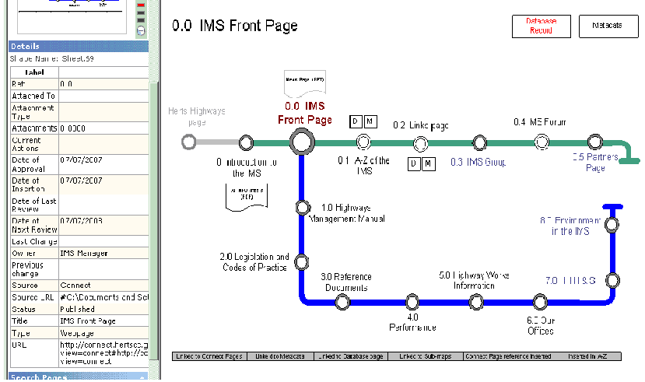

Database page displayed

Status bar

The status bar was something that I found of great use and would be indispensable if working in a team. I found that there were tasks common to every page. These tasks were documented in the boxes at the bottom of the map page. Once I had completed the task I could then ‘grey’ it out so that I knew that it had been completed and only the tasks in the ‘white’ boxes needed to be done. If a task did not apply to a page it was ‘blacked out’ (that is black background with white lettering).

This approach to content inventory should yield more value that the normal approach e.g. using just an Excel spreadsheet. Before coding your first page it might be wise to start with the maps, creating as much structure as possible and then validating it with clients and users (most people ‘get it’ straight away as it is a well known paradigm. But one caveat, I sometimes needed to explain that you don’t need to go through one ‘station’ to get to another). Spending time planning the site at this early stage, especially when able to build in user research, should save a lot of time down the line.

This approach provides a tool that can be used throughout the lifetime of a website. It starts off as a development tool, allowing the structure to be considered and documented without the distractions of other irrelevant information. Throughout development the map can be iteratively assessed and amended and the database pages can be used for notes. The use of the status bar or similar can provide a quick indication of progress to date for each page.

The map, being a webpage, can be easily accessed and can be made available to stakeholders during the development phase if required. This way clients, and even users if an intranet, can follow progress without having to be updated by the development team.
Finally when the project is complete the content inventory can be handed over to whoever is managing the site as a tool for maintaining the site and controlling content. It could even be made available to users as an alternative way of navigating the website.

